CS331 Project 2 Problems – Ben Webb

1. I used the command whois colby.edu because that is Colby’s homepage. I also repeated the command but with the IP of Colby.edu (whois 137.146.24.72)
   1. The domain name is Colby.edu. This is reported in whois colby.edu.
   2. The nameservers are NS1.P28.DYNECT.NET, NS2.P28.DYNECT.NET, NS3.P28.DYNECT.NET, and NS4.P28.DYNECT.NET. This is reported in whois Colby.edu.
   3. The IP range is 137.146.0.0 - 137.146.255.255. This is reported in whois 137.146.24.72.
   4. The prefix is 16. This is reported in whois 136.146.24.72

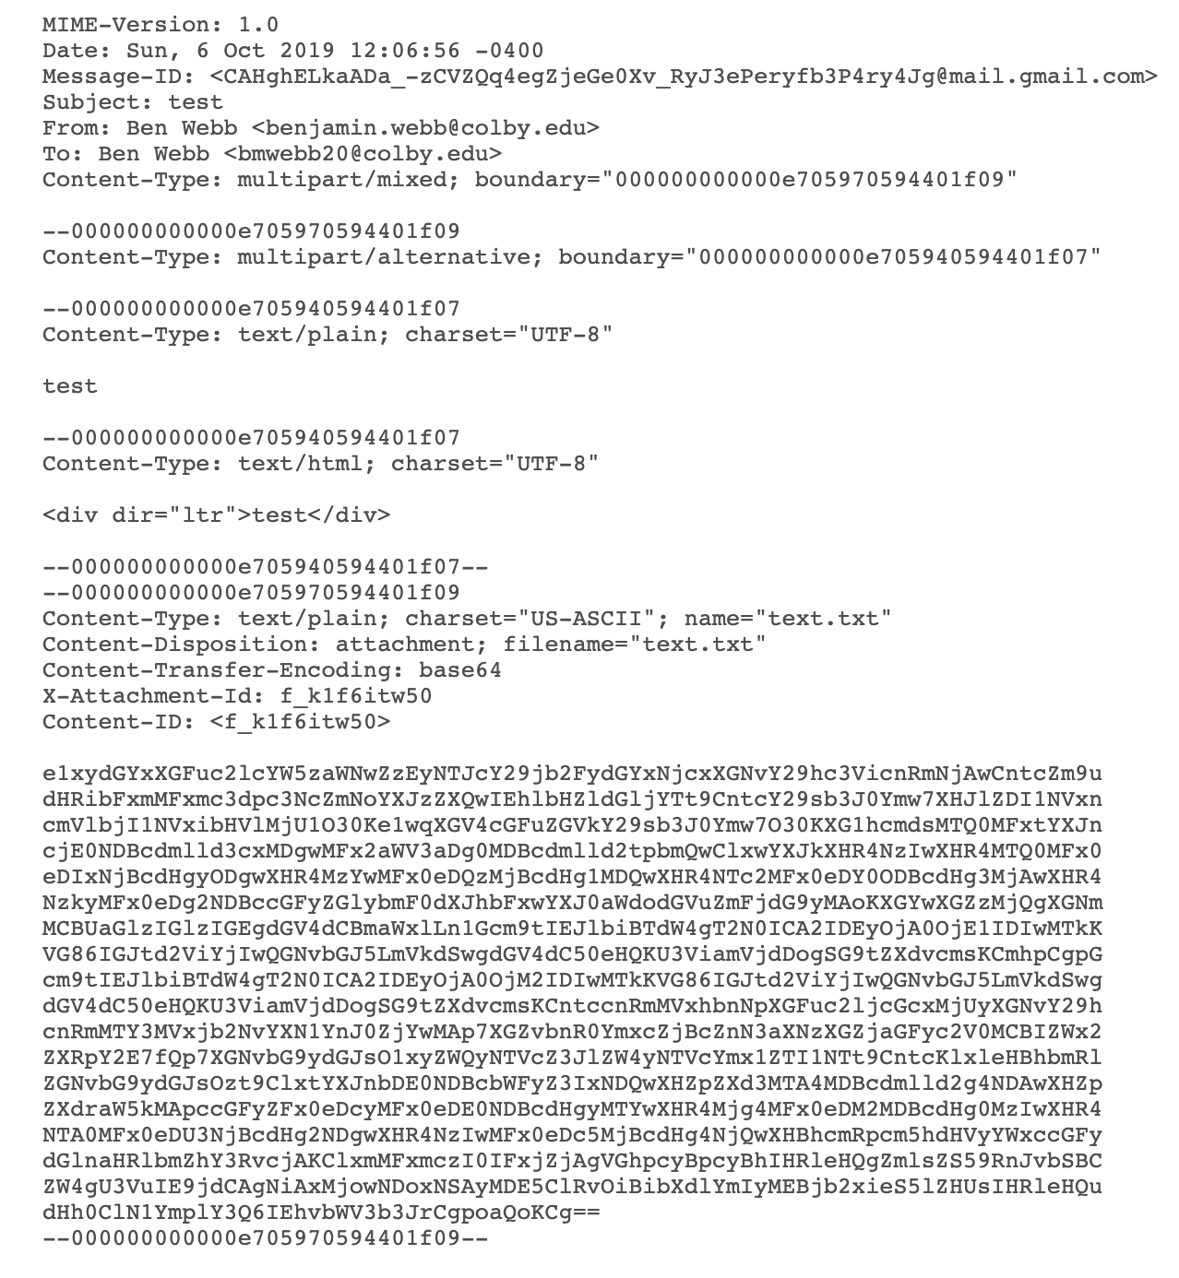

The first section describes the Mime version, the date, the sender and receiver, as well as the overall content of the message.

The second section describes if there is any complex information (fonts) and how to find a simpler (and compatible) state.

The third section describes the text content of the email as well as including the data.

The fourth section describes the content of the email that is interpretable in html.

The fifth section describes the content of the attachment. The headers describe the type of file that was attached. In this case it was a text file. Mime converted the file into a string of ASCII characters which is seen in the large text subsection at the bottom.

1. a. The server port was 587.

b. The encrypted content of the message can be seen but the actual content cannot. It cannot be seen because the message is encrypted.

c. The total bytes transmitted are 1,128. I found this by adding up all of the TLSv1.0 that happened after the exchange of the cipher. The discrepancy between the two is because the message has been encapsulated by the time that the message is captured and thus has additional identifier information.

d. The server is using ESMTP but with TLS security. TLSV1.0 is not the most up to date version of TLS.

e. The server is located in the Kansas (MST). I found this by tracking the IP of the destination.

1. I found most of the information for this using this [Link](https://developer.mozilla.org/en-US/docs/Web/HTTP/Headers).

a. I connected to our project 2 website at the URL: <http://cs.colby.edu/courses/F19/cs331/projects/p2.html>

The result was:

HTTP/1.1 200 OK **-> The HTTP response was accepted.**

Date: Sun, 06 Oct 2019 18:11:29 GMT **-> The time.**

Server: Apache/2.4.6 (Red Hat Enterprise Linux) PHP/5.4.16\r\n **-> Server Information**

Connection: Keep-Alive\r\n **-> The connection characteristic (keep alive)**

Keep-Alive: timeout=5, max=100\r\n **-> Keep the connection alive with a max time of 100 and timeout of 5 seconds**

ETag: “1c53-59377e0a99eee”\r\n **-> This is part of web caching which allows the client to make conditional requests**

\r\n

b. I created a local server using the command: nc -l 80

When I tried to connect to localhost:80 on Chrome the result in the console was:

GET / HTTP/1.1 **-> The HTTP response was received.**

Host: localhost **-> The host of the server.**

Connection: keep-alive **-> The type of connection.**

Cache-Control: max-age=0 **-> Specifies how caching will happen.**

DNT: 1 **-> Do not track (0 = tracking ok, 1 = tracking not ok)**

Upgrade-Insecure-Requests: 1 **-> The client prefers an encrypted connection.**

User-Agent: Mozilla/5.0 (Macintosh; Intel Mac OS X 10_14_6) AppleWebKit/537.36 (KHTML, like Gecko) Chrome/77.0.3865.90 Safari/537.36 **-> Describes the compatibility of the application.**

Accept: text/html,application/xhtml+xml,application/xml;q=0.9,image/webp,image/apng,*/*;q=0.8,application/signed-exchange;v=b3 **-> Describes what content types the client can understand.**

Accept-Encoding: gzip, deflate, br **-> Describes what content encoding the client can understand.**

Accept-Language: en-US,en;q=0.9 -> **Describes what language types the client can understand.**